Task isn’t clear
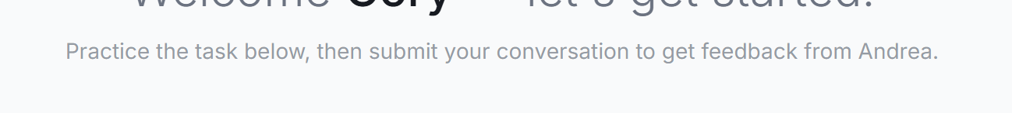
In the interface orientation module in session 1, the AI review is too restrictive to move the user forward. It’s pretty clear that the review function doesn’t know when you start a new chat (like the review only occurs on the existing chat).
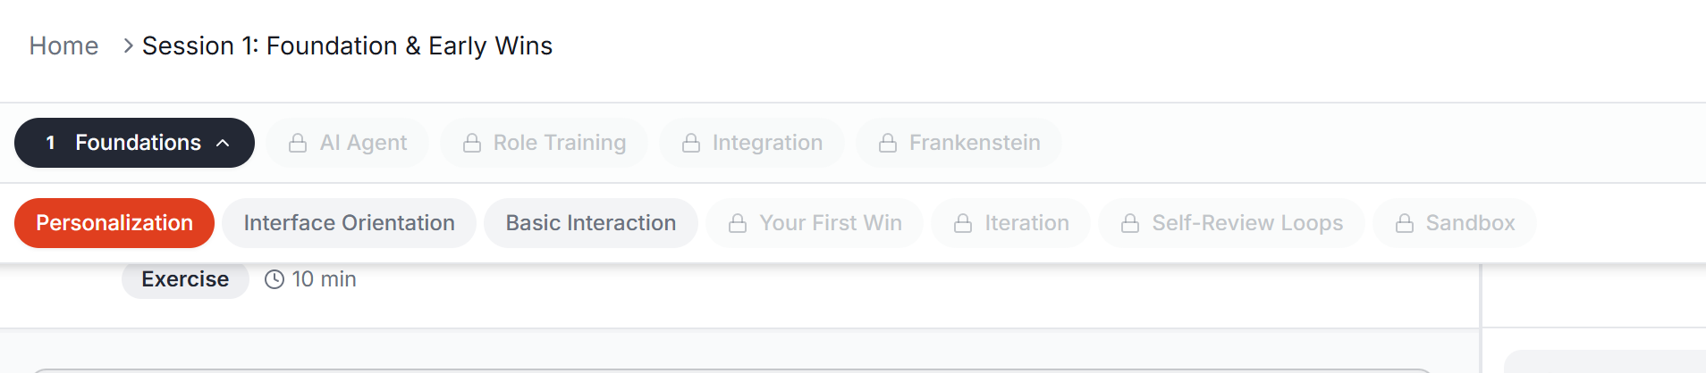
I reset the full training and the first 3 modules are unlocked. But every module should be locked until the prior module is unlocked.

The AI Brainstorm should have conversation history and new chat functionality.
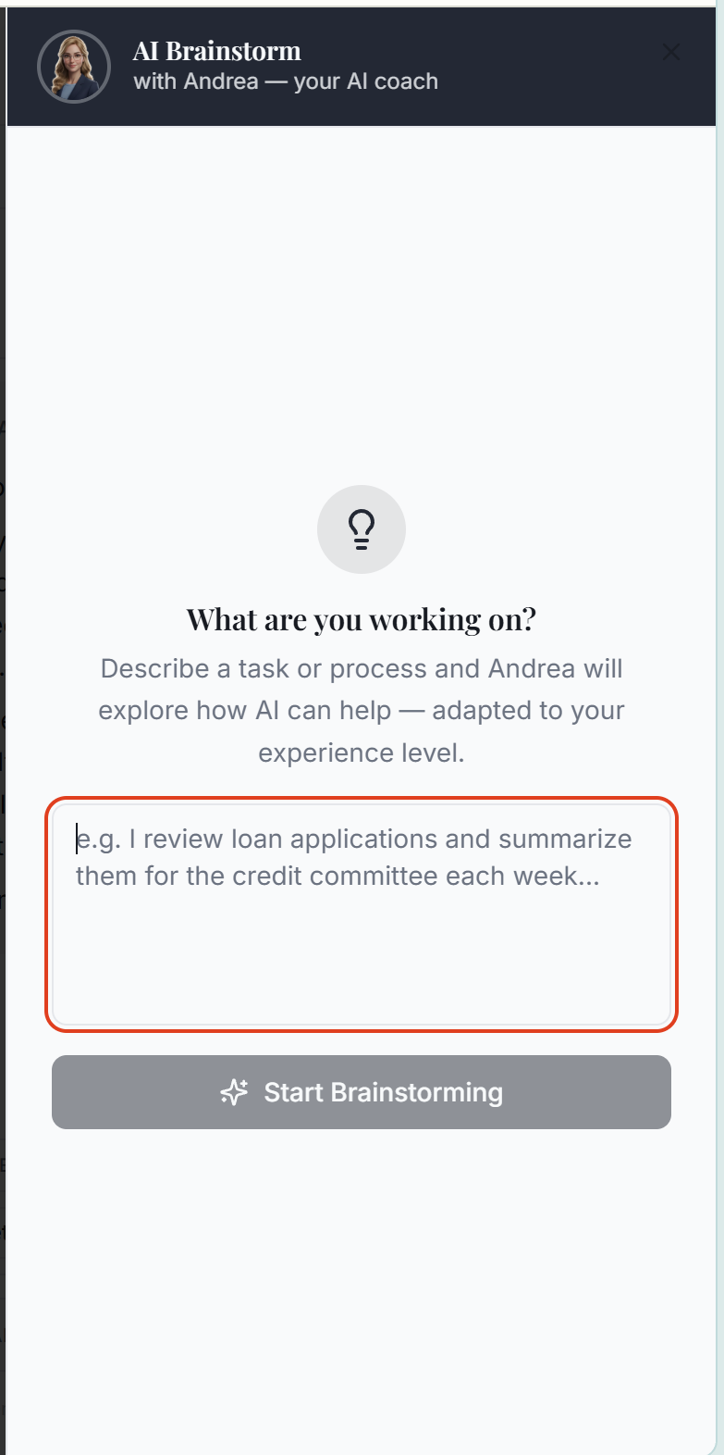
When completing step 2 of the intake form where you define your role, if you click Other, it should allow you to input what your role is.
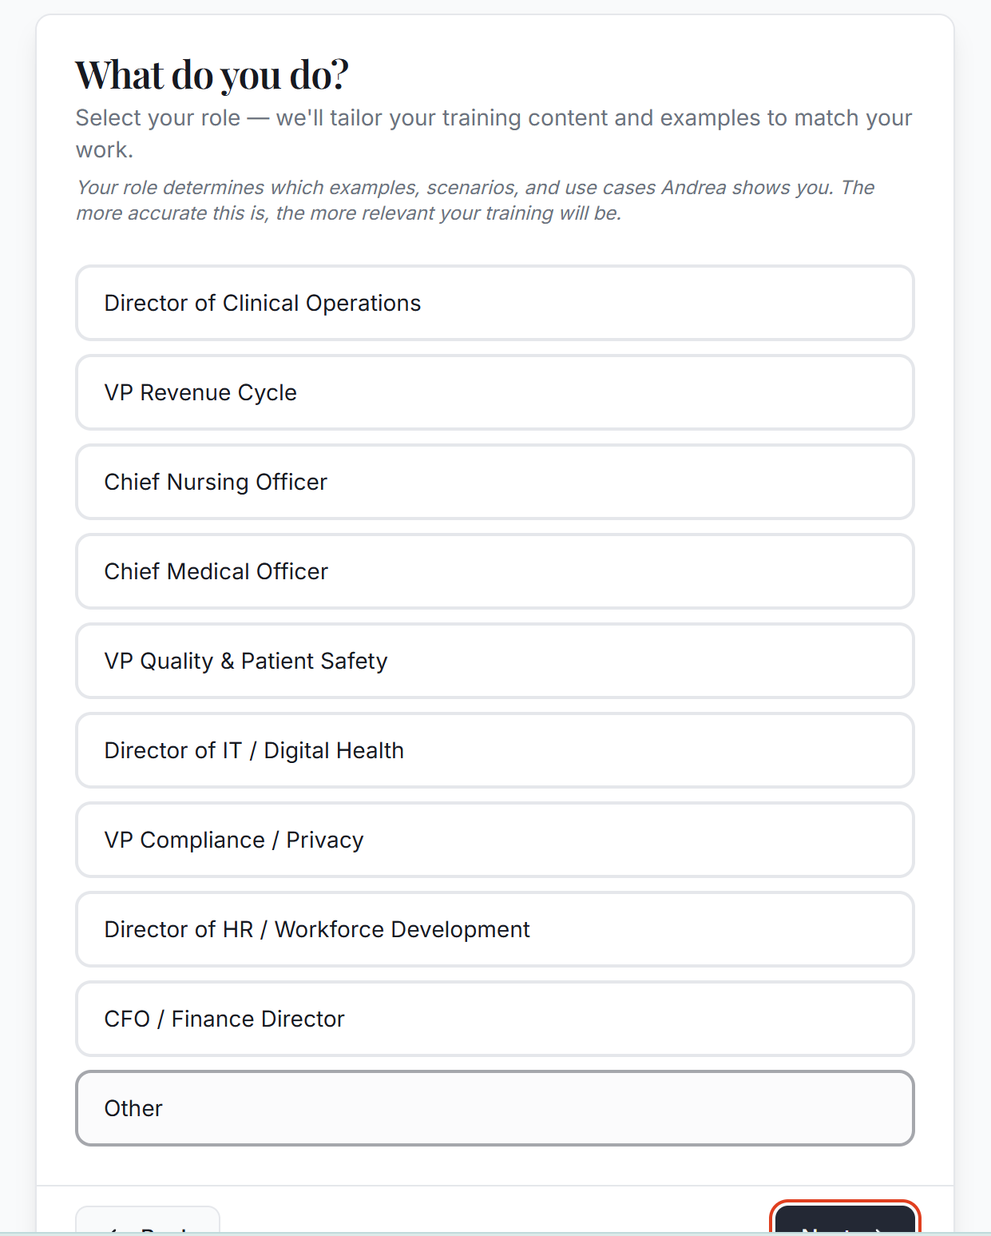
The login screen says uses you@bank.com as the greyed out example. It should be you@abc.com
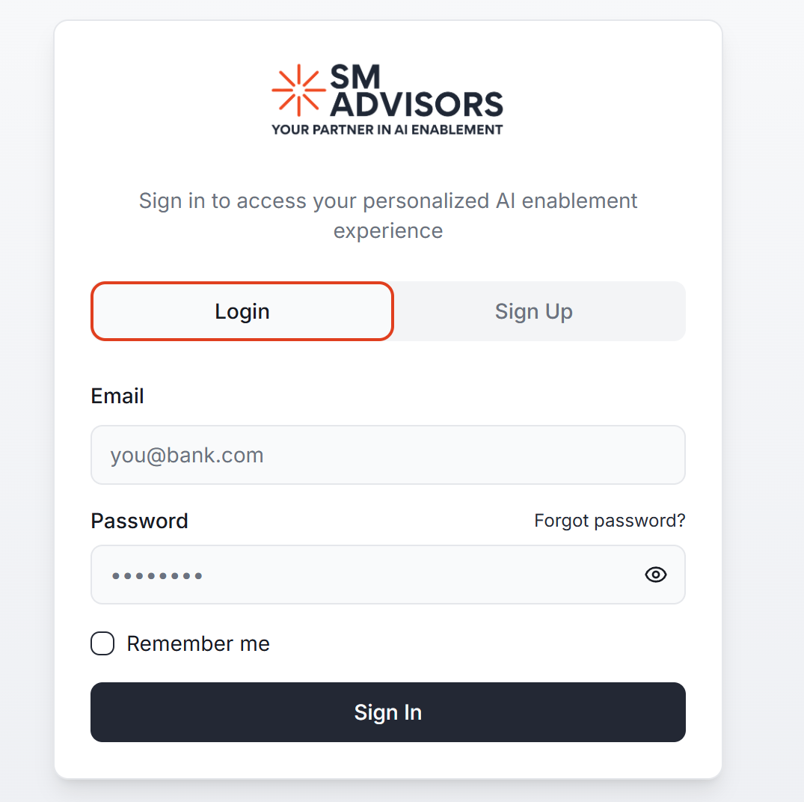
In the SuperAdmin view, I don’t see any organizations or users anymore. There are organizations and existing users on the platform.
